Part A — Practice Programs (Hour 1)
Work these in your lab-NN/ folder before the project: do the first one or two in the lab; the
last (For Advanced Learners) is for home.
1. Counter race: several threads each increment a shared counter many times. Run it
without synchronization to watch the total come out too low, then make the increment
synchronized and confirm it is exactly right every run.

class CounterRace {
static int count = 0;

static synchronized void increment() {
count++;
}

public static void main(String[] args) throws InterruptedException {
Thread t1 = new Thread(() -> {
for (int i = 0; i < 100000; i++) {
count++; // Without synchronization
}
});

Thread t2 = new Thread(() -> {
for (int i = 0; i < 100000; i++) {
count++; // Without synchronization
}
});

t1.start();
t2.start();

t1.join();
t2.join();
System.out.println("Without synchronization: " + count);
count = 0;
Thread t3 = new Thread(() -> {
for (int i = 0; i < 100000; i++) {
increment();
}
});
Thread t4 = new Thread(() -> {
for (int i = 0; i < 100000; i++) {
increment();
}
});
t3.start();
t4.start();
t3.join();
t4.join();
System.out.println("With synchronization: " + count);
}
}

Output:
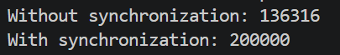

2. Seat booking race: a shared seatsLeft of 5 with about 10 threads each trying to book one
seat. Without synchronization show that more than 5 can succeed (oversell); with a
synchronized book() exactly 5 do.
class SeatBookingRace {
static int seatsLeft = 5;
static int booked = 0;
static synchronized void book() {
if (seatsLeft > 0) {
seatsLeft--;
booked++;
System.out.println("Seat booked");
} else {
System.out.println("No seats available");
}
}
public static void main(String[] args) throws InterruptedException {
Thread[] threads = new Thread[10];
for (int i = 0; i < 10; i++) {
threads[i] = new Thread(() -> book());
}
for (int i = 0; i < 10; i++) {
threads[i].start();
}
for (int i = 0; i < 10; i++) {
threads[i].join();
}
System.out.println("Seats left: " + seatsLeft);
System.out.println("Total booked: " + booked);
}}
Output:
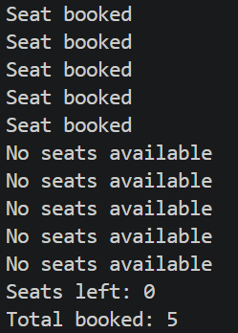

Key Questions / Analysis / Interpretation :
1. What is a race condition, and why does it occur here?
A race condition occurs when multiple threads access and modify shared data at the same time, producing unpredictable results. In MiniBank, concurrent deposits can cause an incorrect balance if updates are not synchronized.
2. What does the synchronized keyword do?
It allows only one thread at a time to execute a synchronized method or block using the same monitor lock. This protects shared data from conflicting updates.
3. What are the states in a thread's life cycle?
Java defines these thread states:
- NEW — thread created but not started.
- RUNNABLE — ready to run or running.
- BLOCKED — waiting to acquire a monitor lock.
- WAITING — waiting indefinitely for another thread's action.
- TIMED_WAITING — waiting for a specified time.
- TERMINATED — execution has finished.

